**AMRUTHESH**

**241059041**

**LINUX OS & SCRIPTING LAB**

**M.E – CYBER SECURITY**

**LINUX OS & SCRIPTING LAB ASSIGNMENT**

**Getting Help**

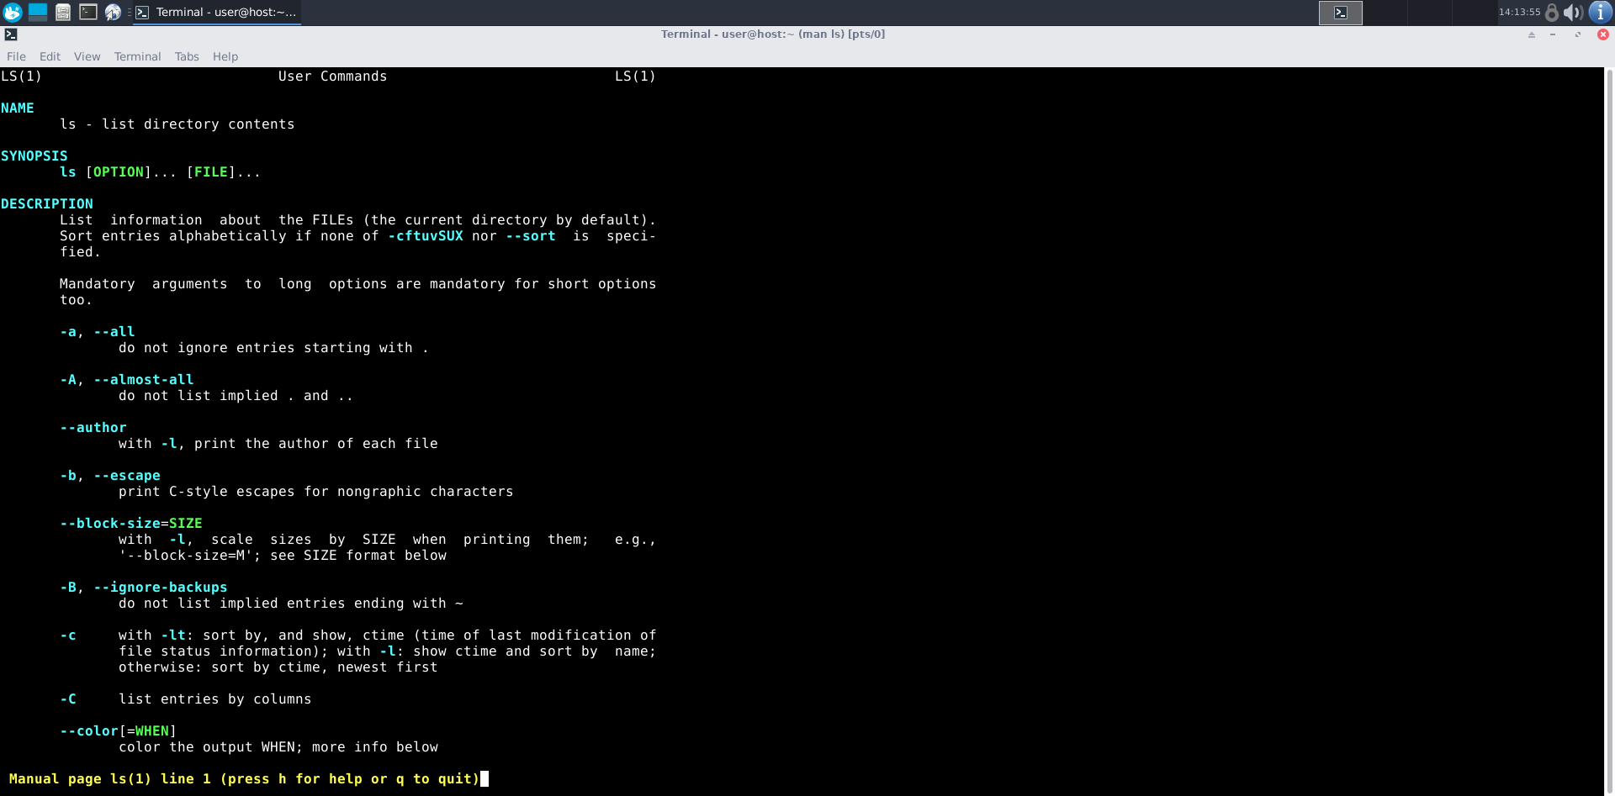

1. To get a manual page for a known command:

- Command Name: man

- Syntax: man [command]

- Example: man ls

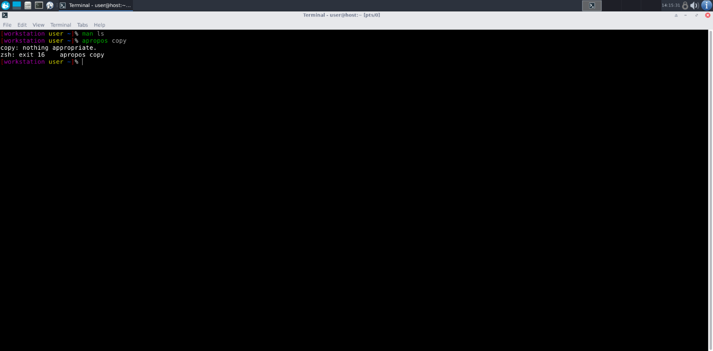

2. To get a manual page for an unknown command:

- Command Name: apropos

- Syntax: apropos [keyword]

- Example: apropos copy

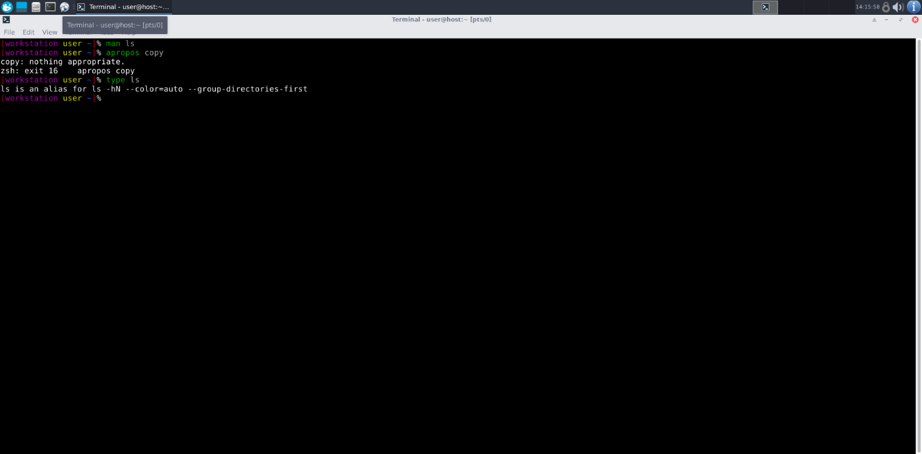

3. To know the source file binary:

- Command Name: type

- Syntax: type [command]

- Example: type ls

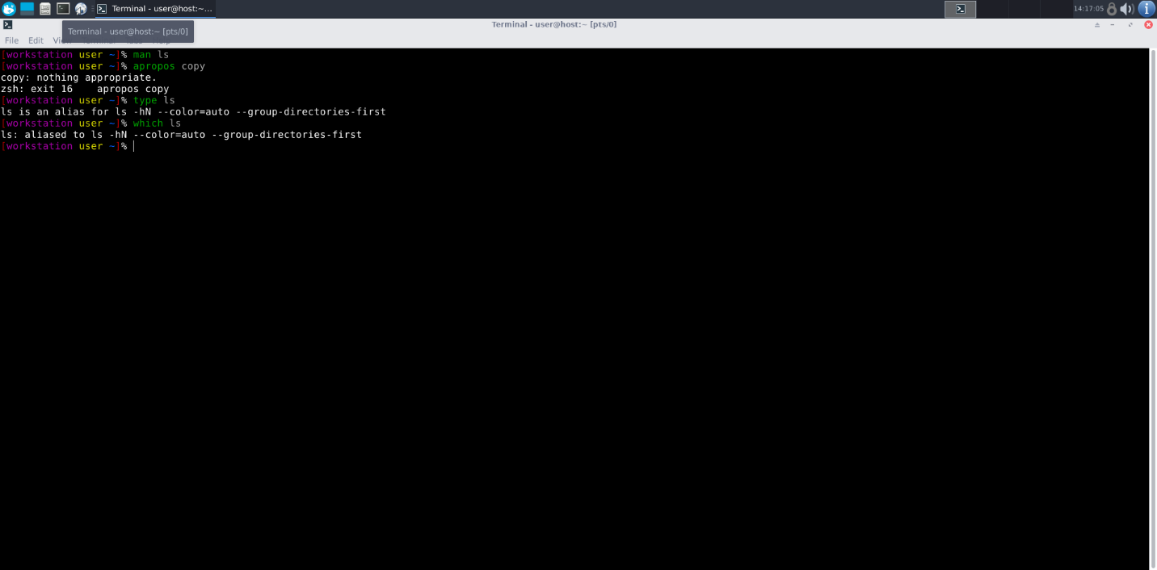

4. To know the path of the command:

- Command Name: which

- Syntax: which [command]

- Example: which ls

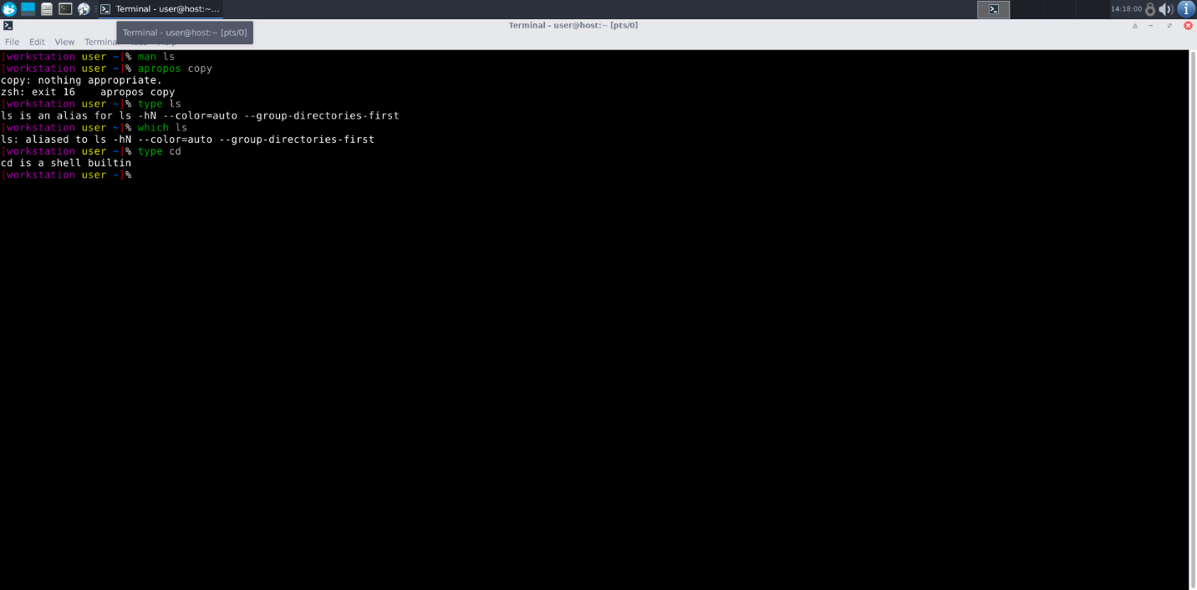

5. To know if the command is external or internal:

- Command Name: type

- Syntax: type [command]

- Example: type cd

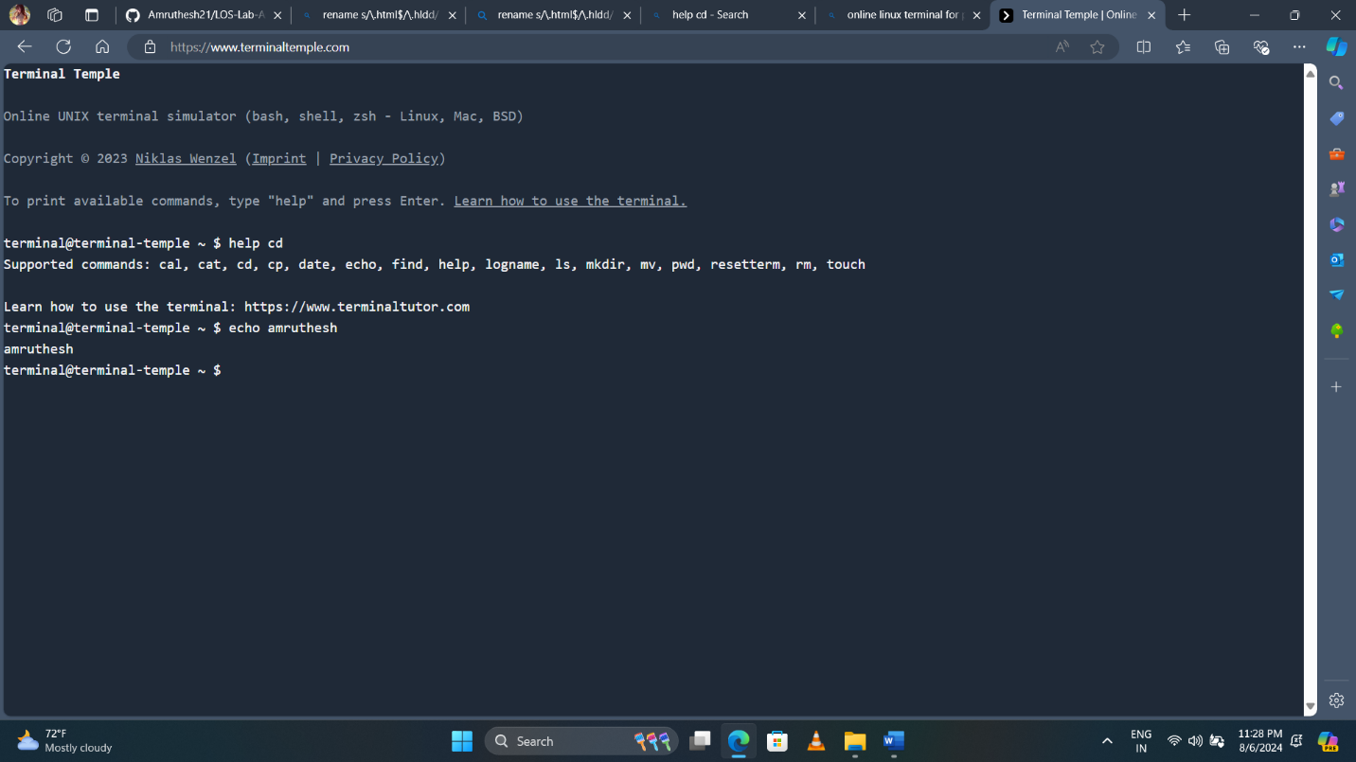

6. To get help for the internal command:

- Command Name: help

- Syntax: help [command]

- Example: help cd

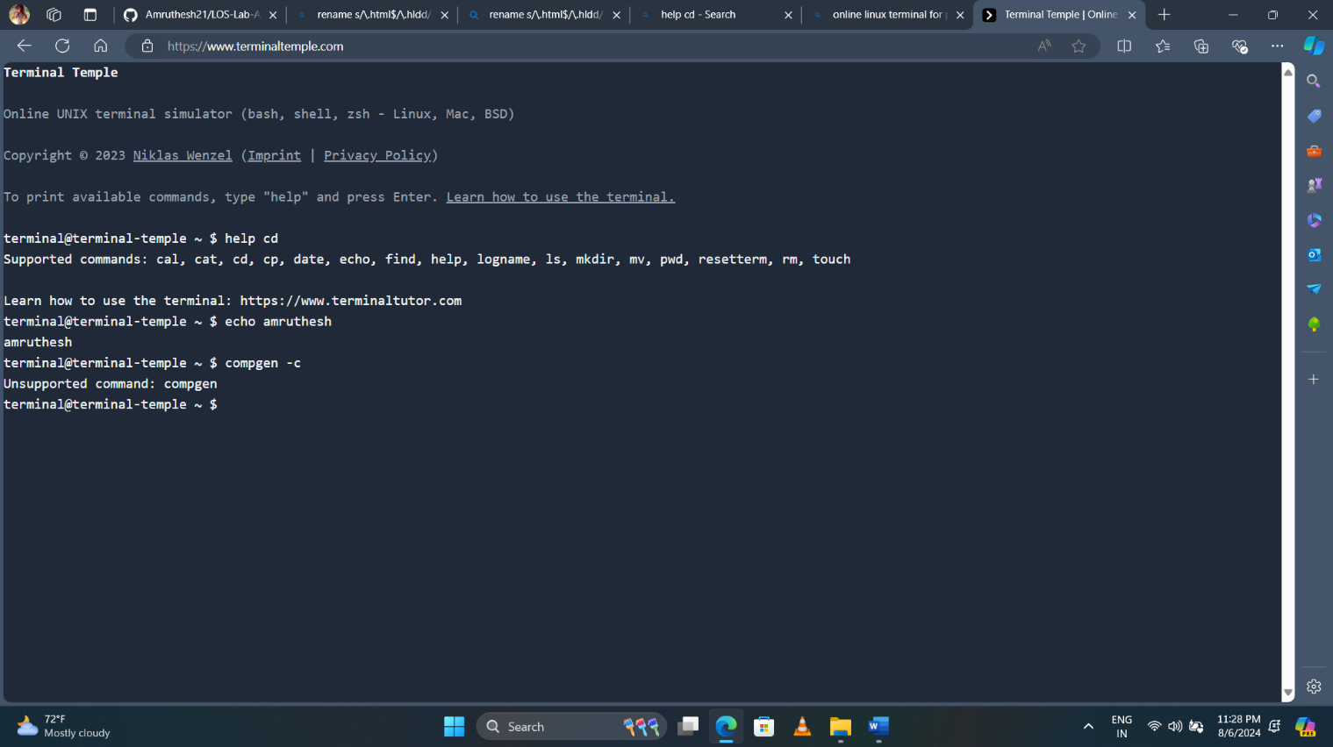

7. To list out bash commands:

- Command Name: compgen

- Syntax: compgen -c

- Example: compgen -c

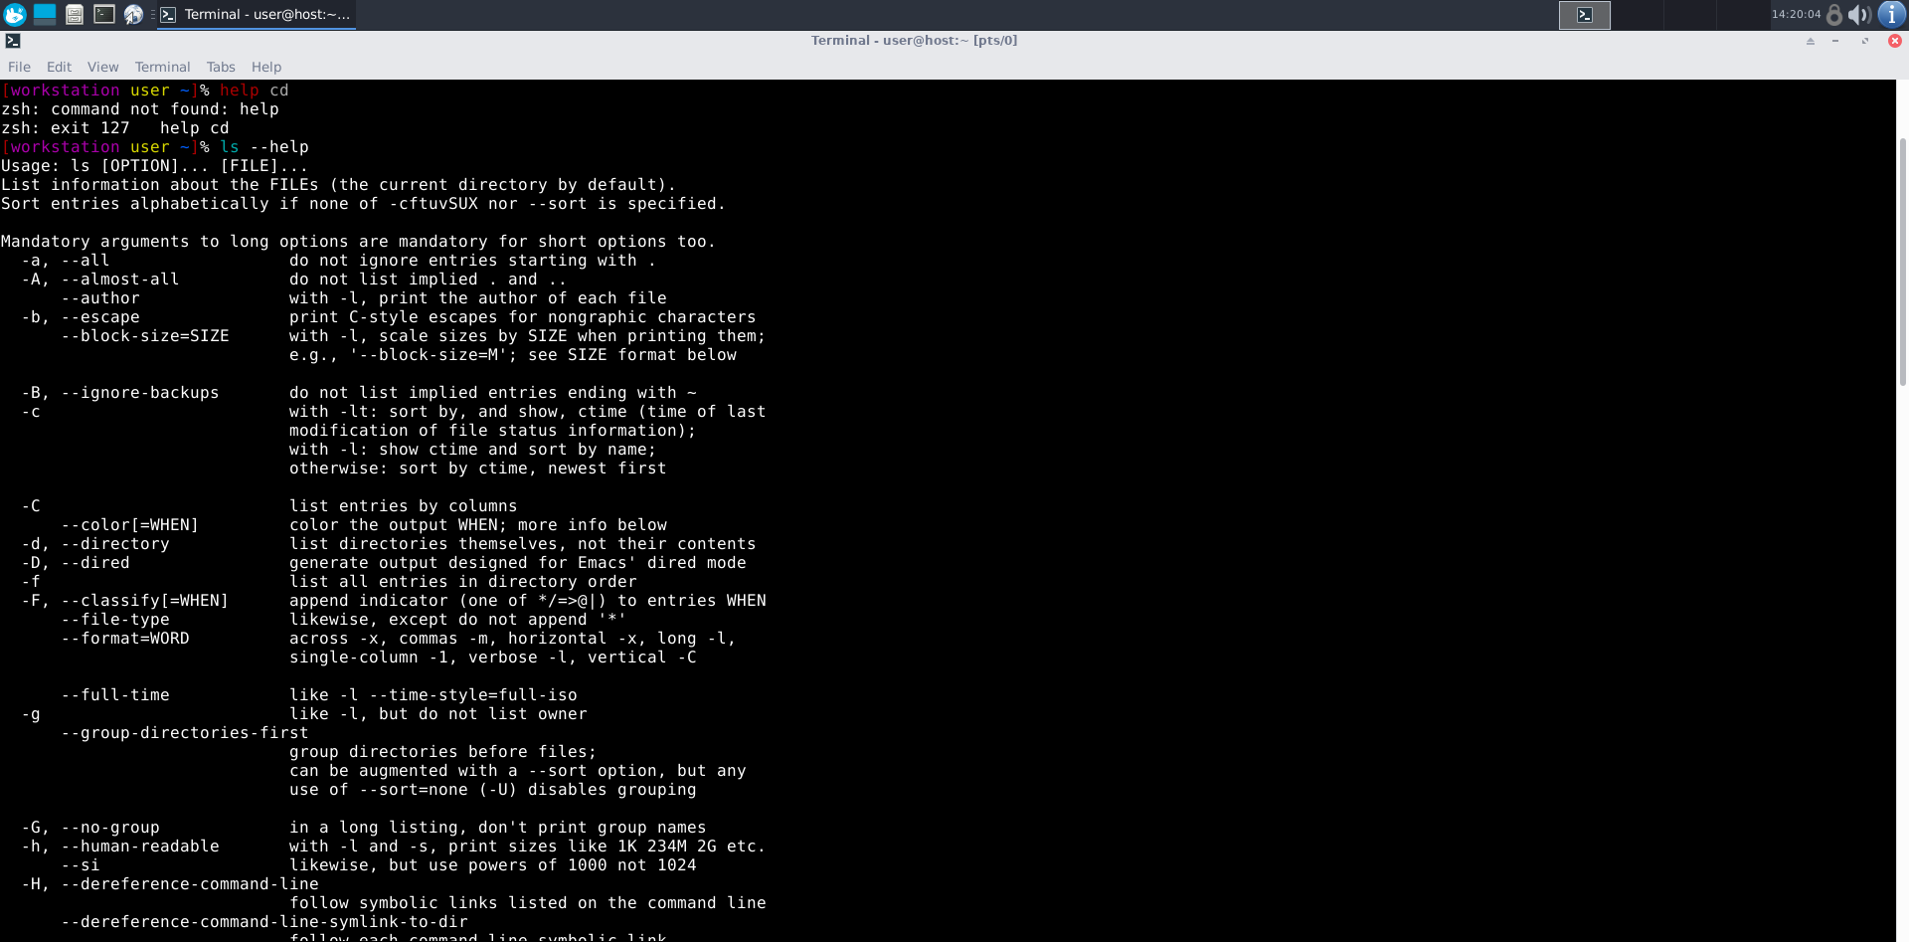

8. To know the usage of the command:

- Command Name: [command] --help

- Syntax: [command] --help

- Example: ls --help

**Basic Commands**

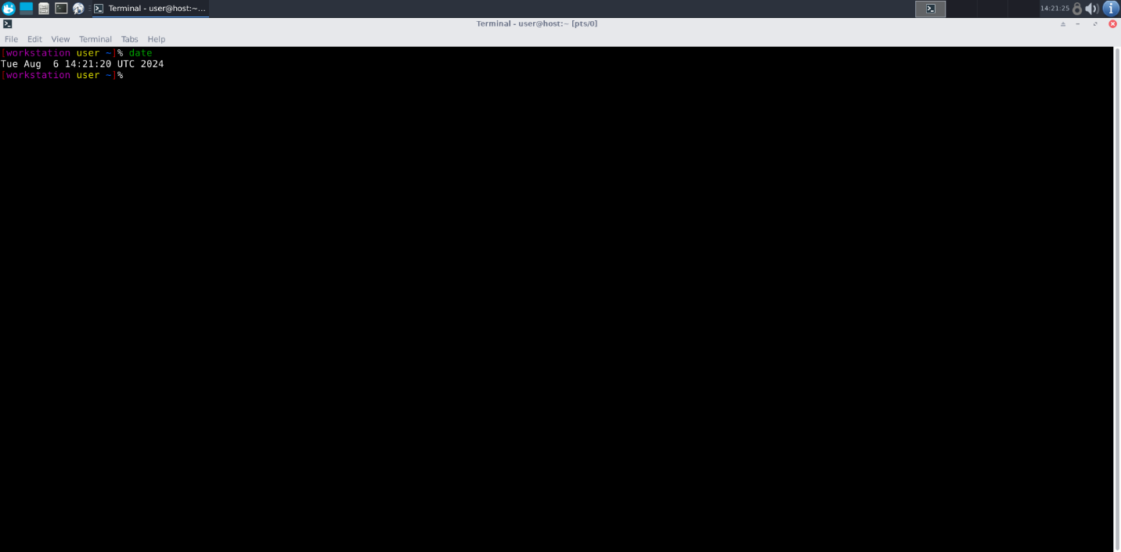

1. To know today ‘s date:

- Command Name: date

- Syntax: date

- Example: date

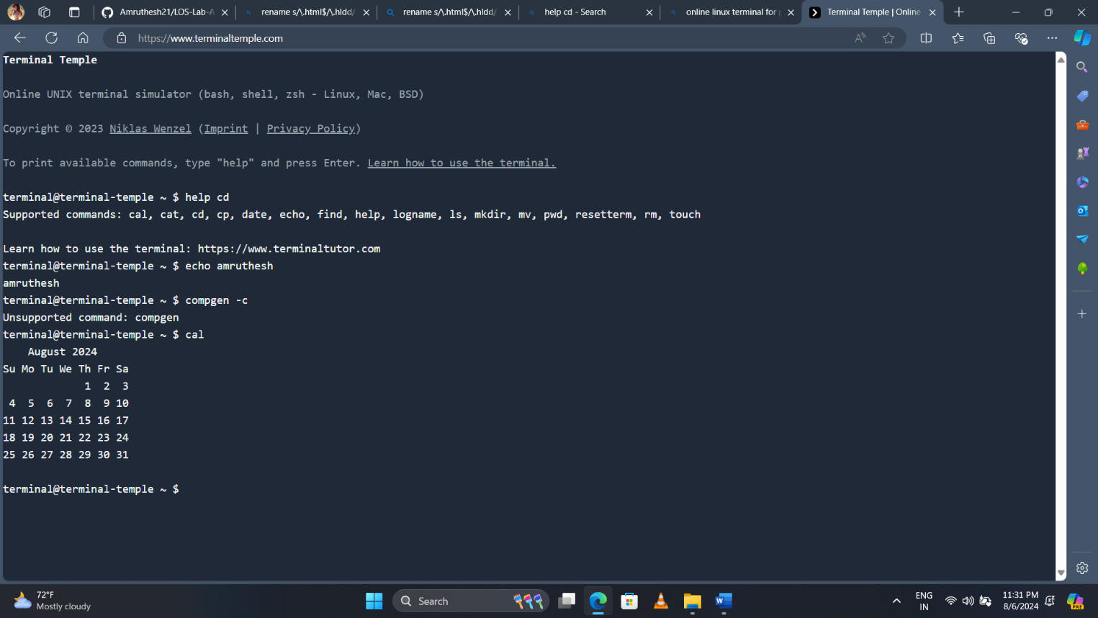

2. To print calendar:

- Command Name: cal

- Syntax: cal

- Example: cal

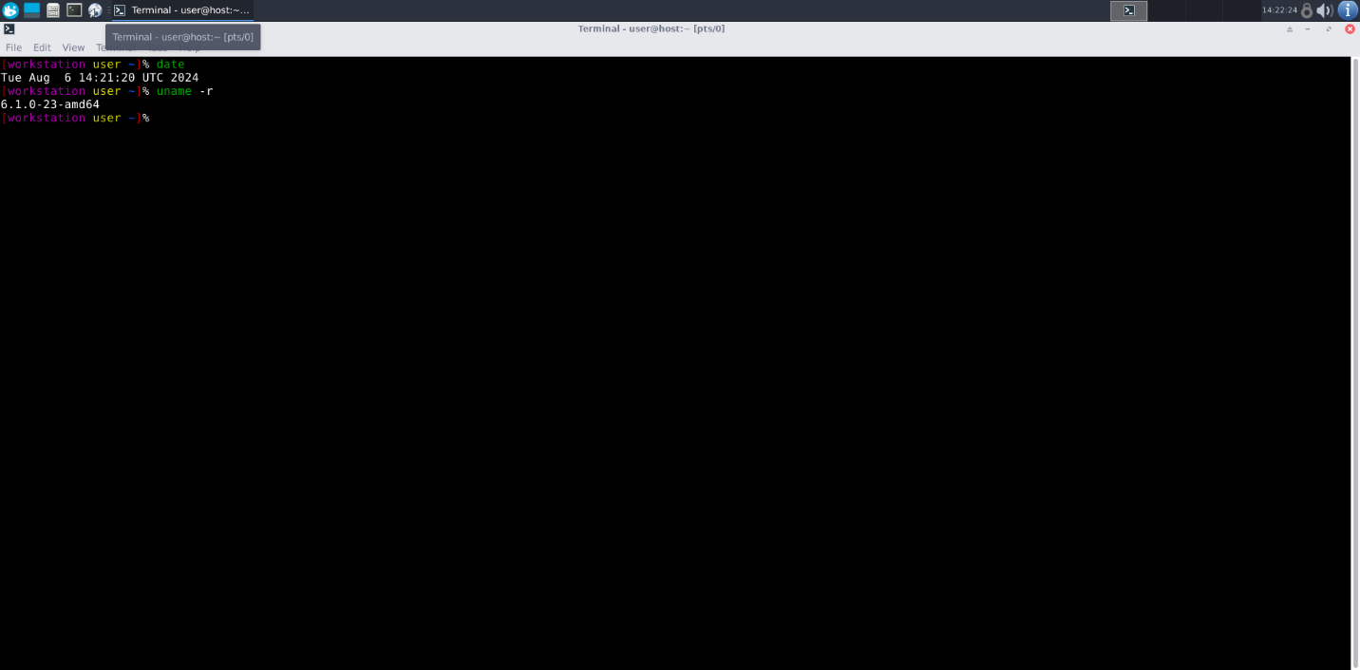

3. To print kernel version:

- Command Name: uname

- Syntax: uname -r

- Example: uname -r

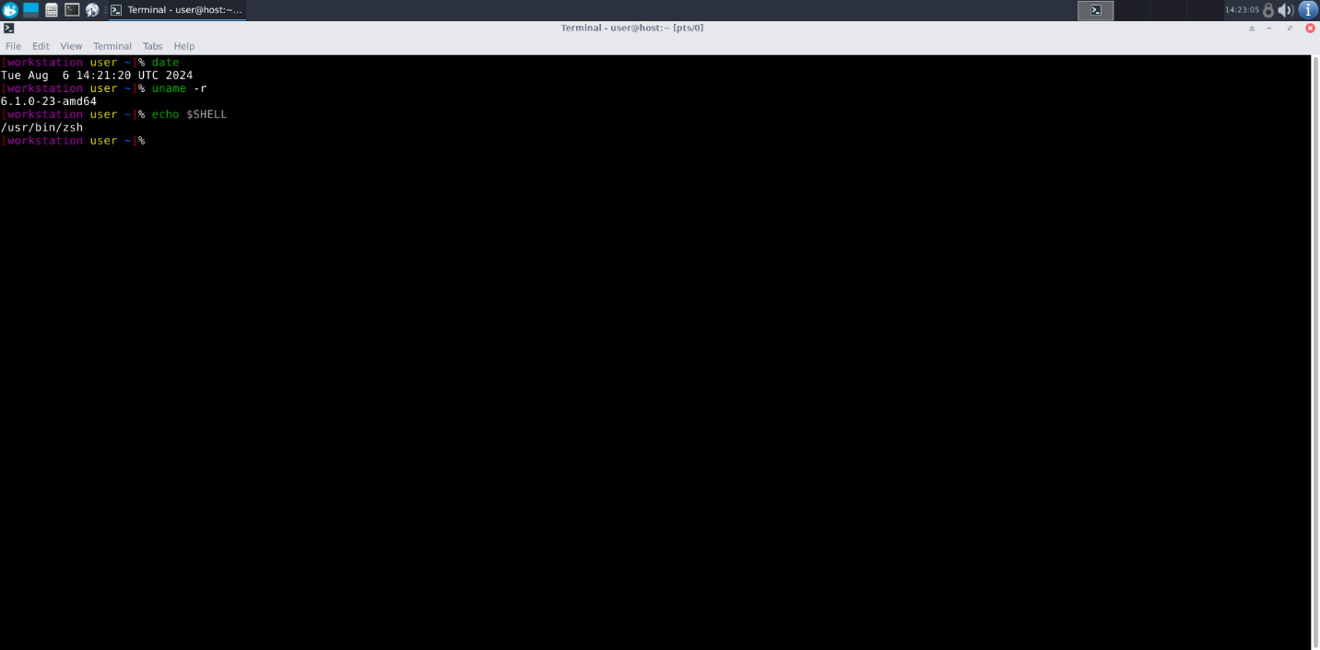

4. To print default shell:

- Command Name: echo

- Syntax: echo $SHELL

- Example: echo $SHELL

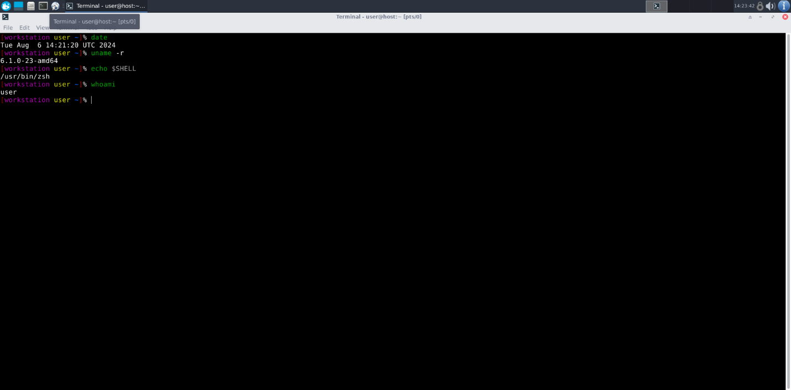

5. To print currently logged in user:

- Command Name: whoami

- Syntax: whoami

- Example: whoami

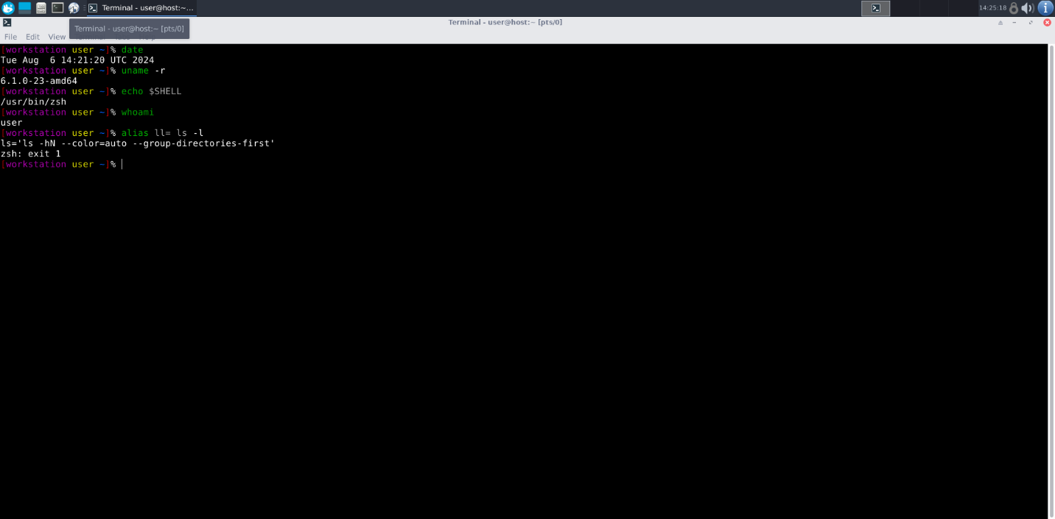

6. To create a shortcut for command:

- Command Name: alias

- Syntax: alias [shortcut_name]= [command]

- Example: alias ll= ls -l

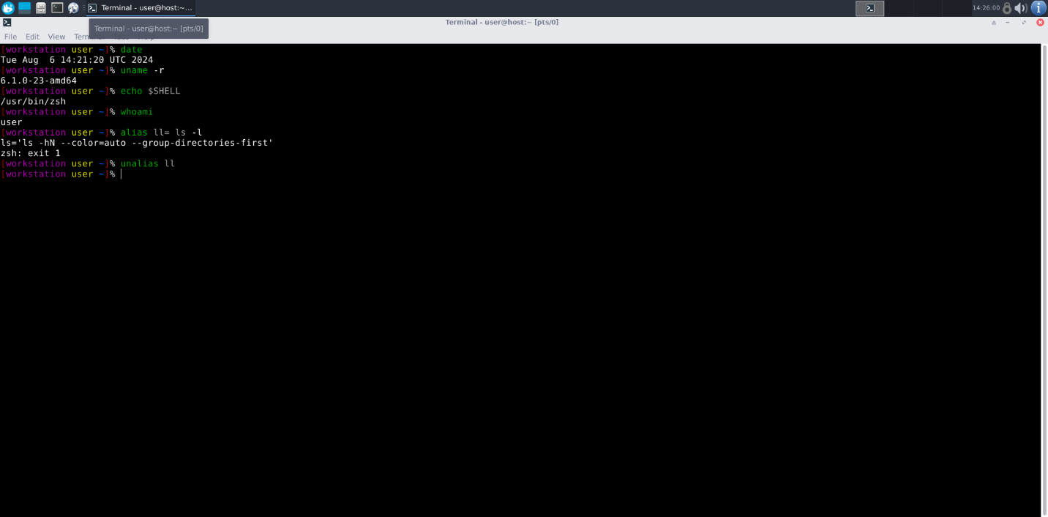

7. To delete shortcut:

- Command Name: unalias

- Syntax: unalias [shortcut_name]

- Example: unalias ll

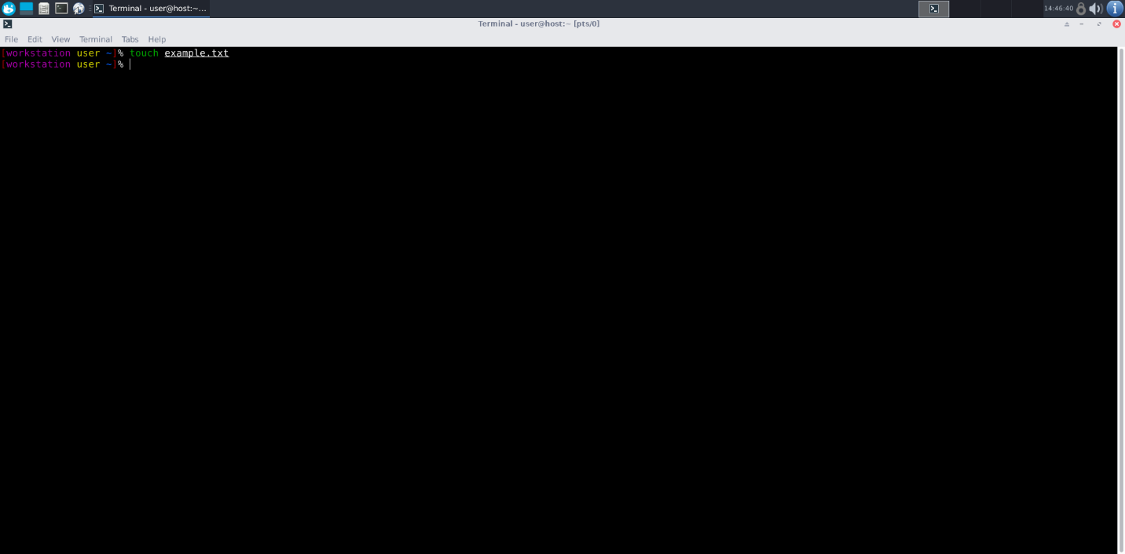

8. To change the timestamp of the file:

- Command Name: touch

- Syntax: touch [file]

- Example: touch example.txt

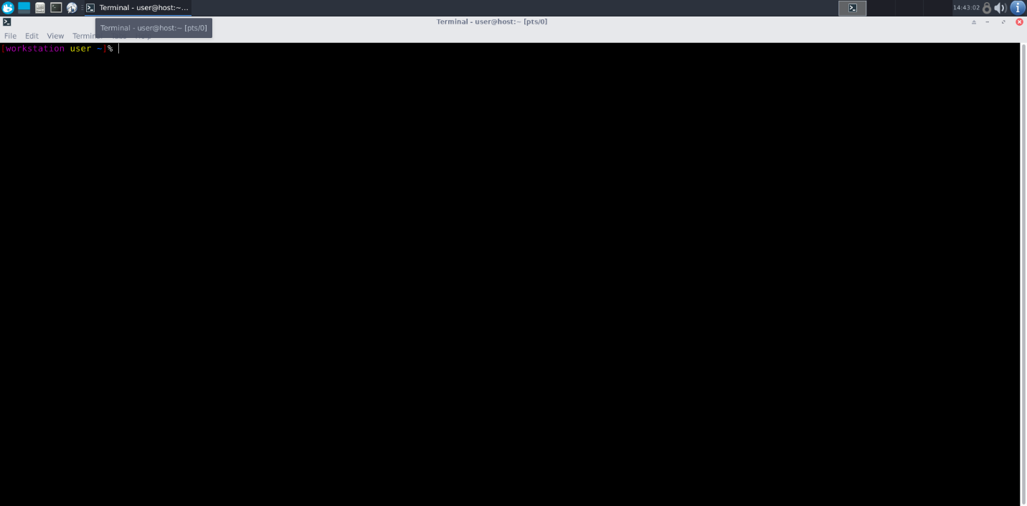

9. To clear the screen:

- Command Name: clear

- Syntax: clear

- Example: clear

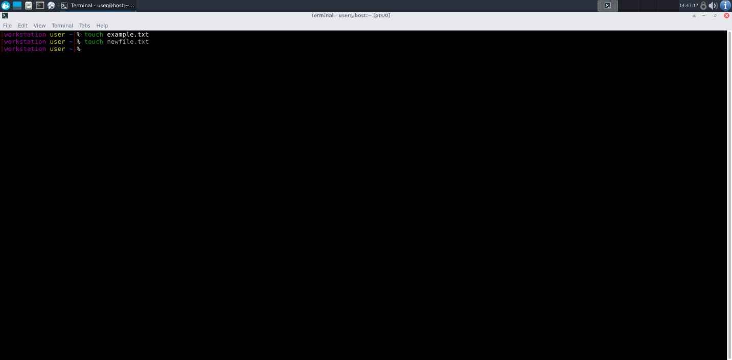

10. To create empty files:

- Command Name: touch

- Syntax: touch [file]

- Example: touch newfile.txt

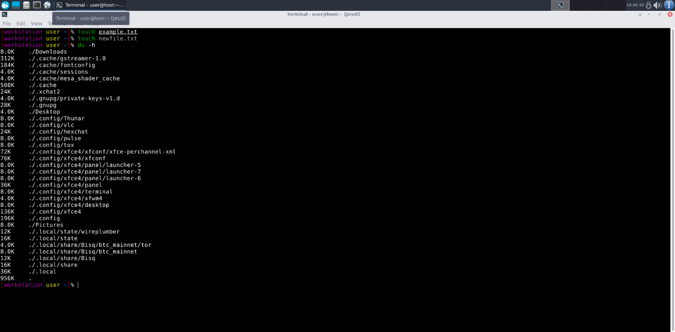

11. To know disk usage:

- Command Name: du

- Syntax: du [options]

- Example: du -h

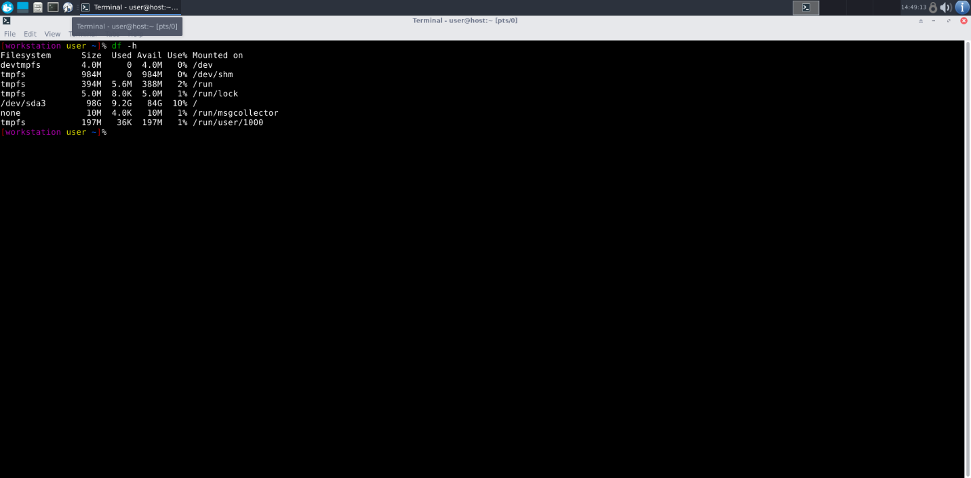

12. To know free space in the system:

- Command Name: df

- Syntax: df [options]

- Example: df -h

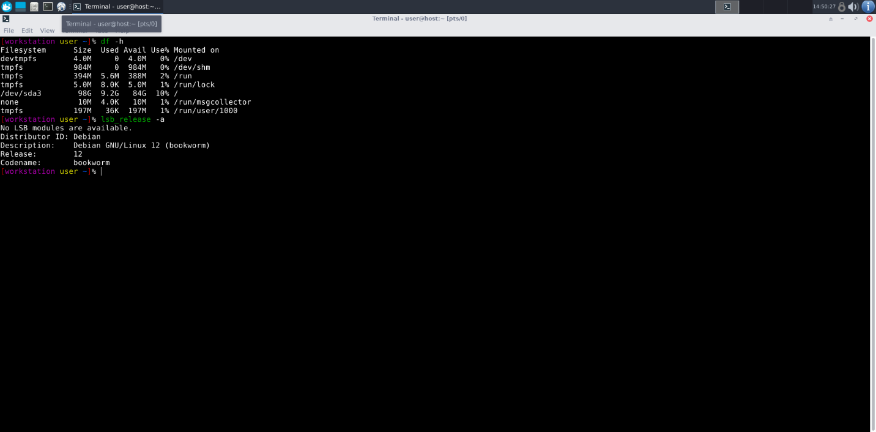

13. To know about the Linux release:

- Command Name: lsb_release

- Syntax: lsb_release -a

- Example: lsb_release -a

**Navigation**

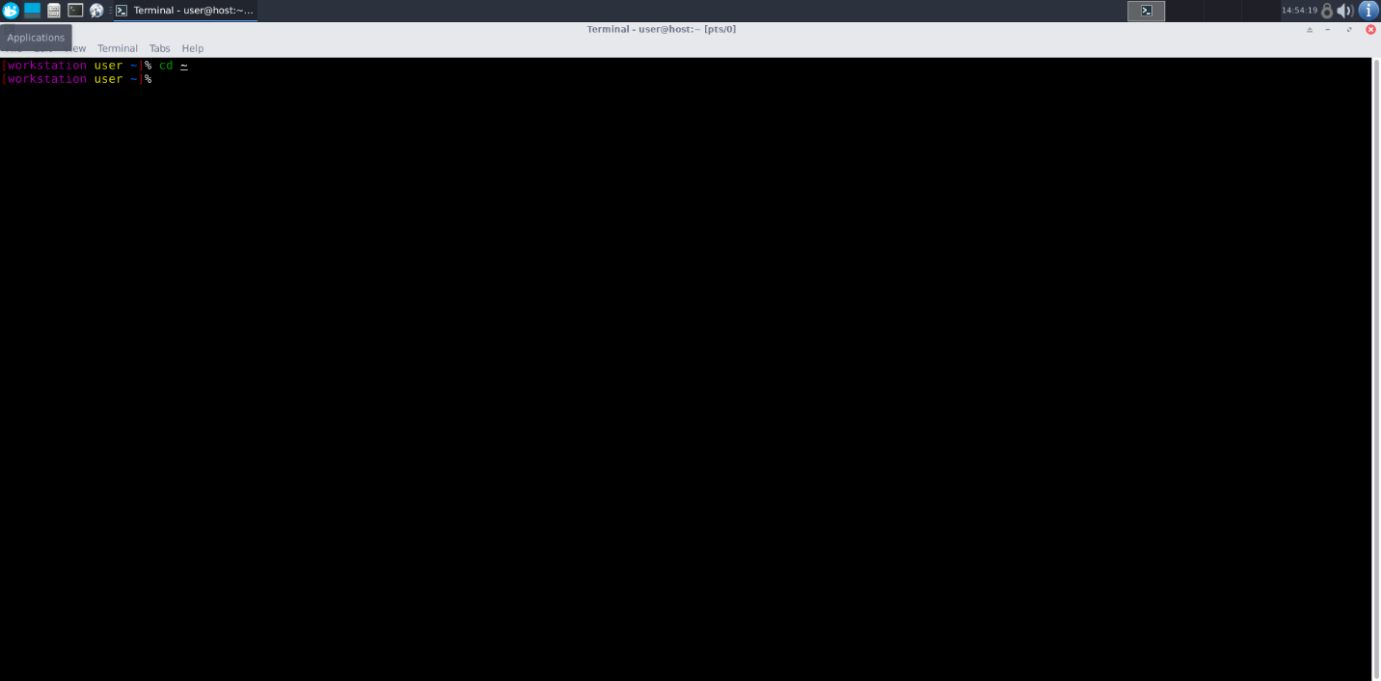

1. To navigate to the home directory:

- Command: cd ~

- Syntax: cd ~

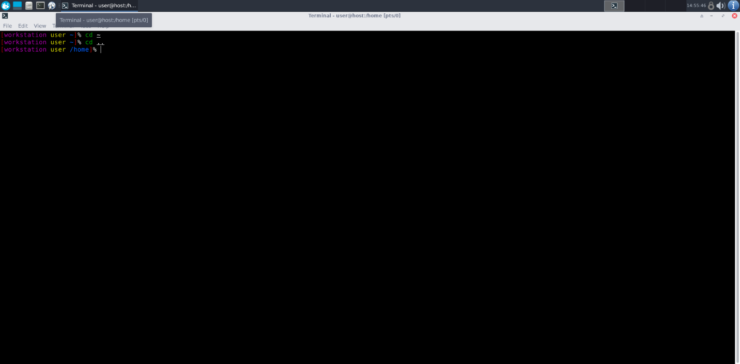

2. To navigate to the parent directory:

- Command: cd ..

- Syntax: cd ..

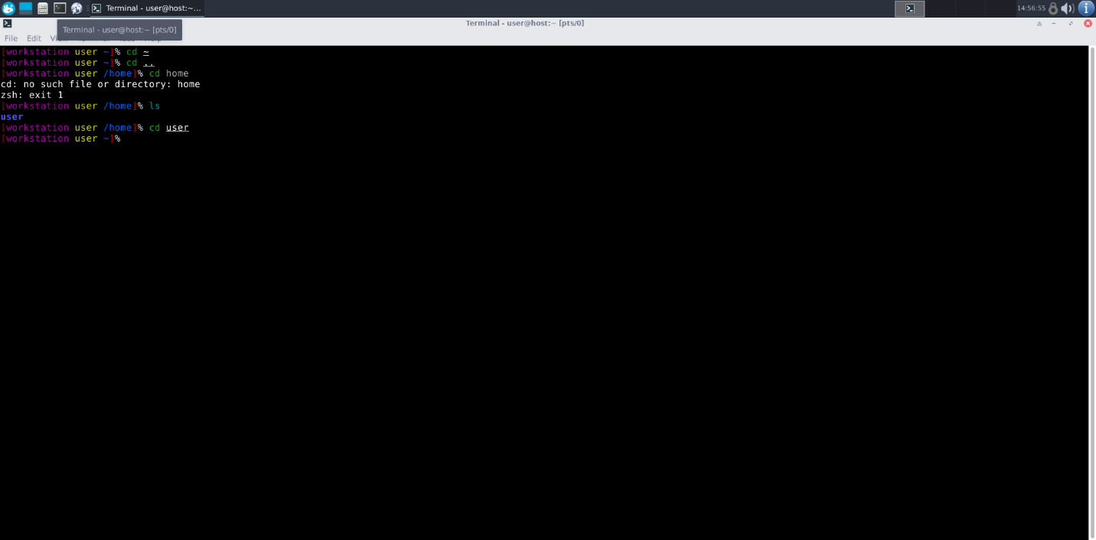

3. To navigate to the child directory:

- Command: cd

- Syntax: cd [directory_name]

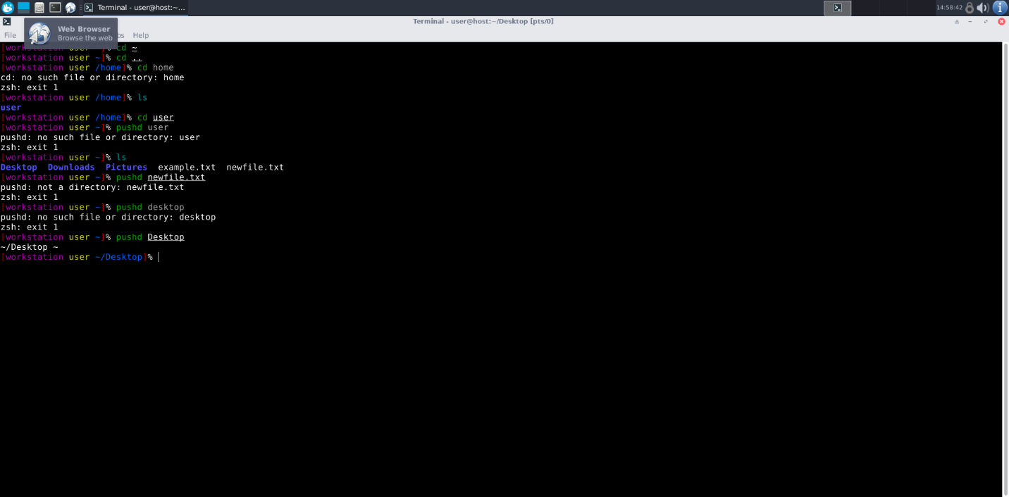

4. Alternate command to cd :

- Command: pushd and popd

- Syntax: pushd [directory] , popd

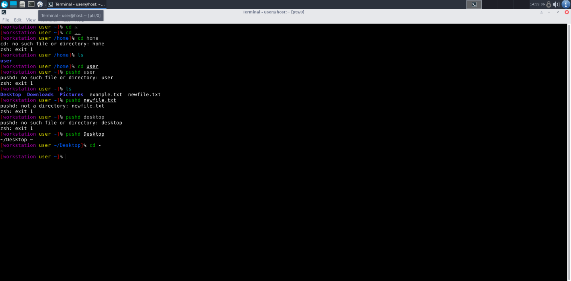

5. To go back to the previous directory:

- Command: cd -

- Syntax: cd -

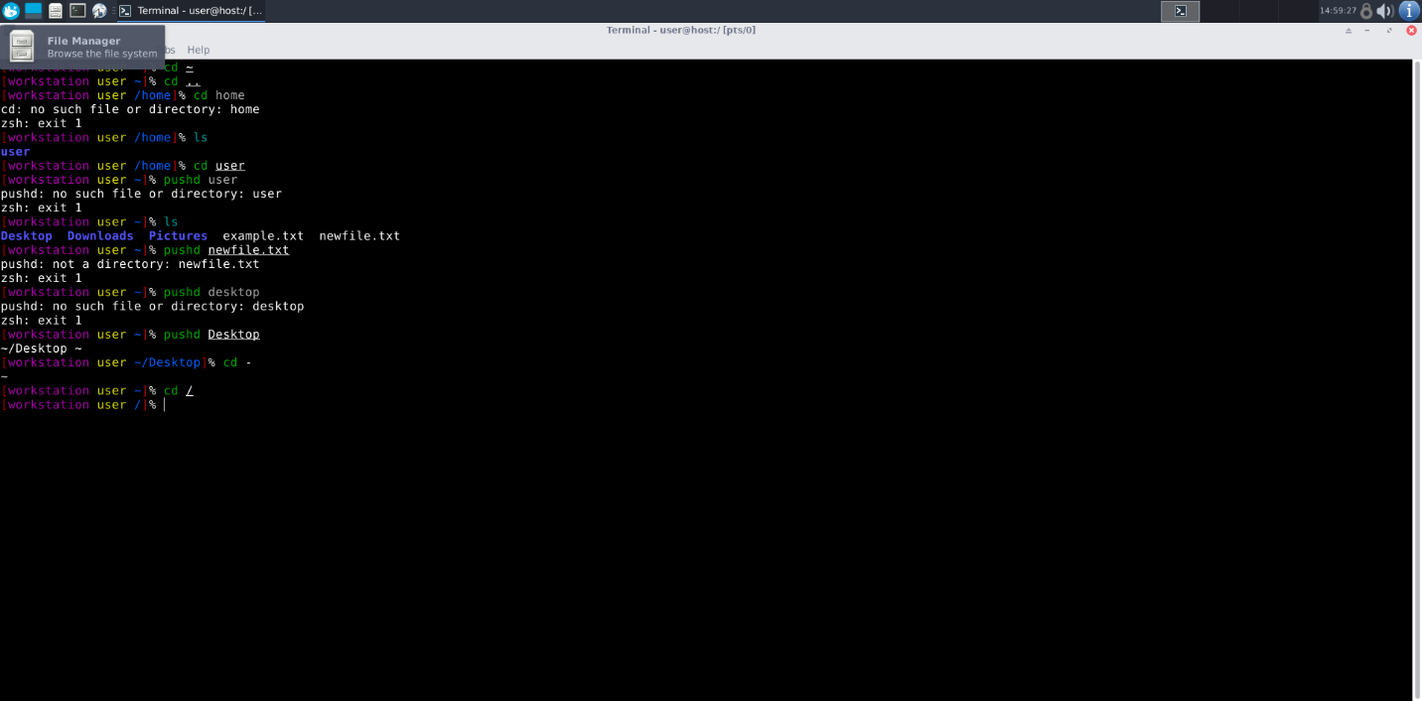

6. To go to the root directory:

- Command: cd /

- Syntax: cd /

**File System**

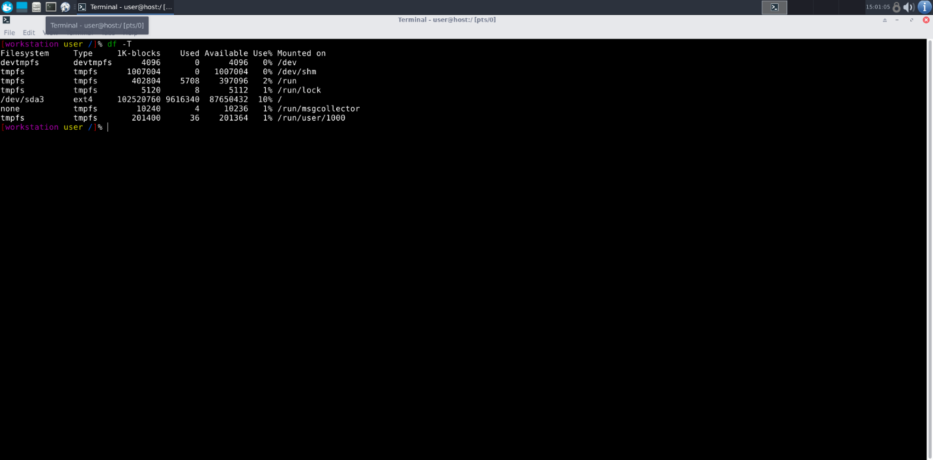

1. How to identify the file system:

- Command: df -T

- Syntax: df -T

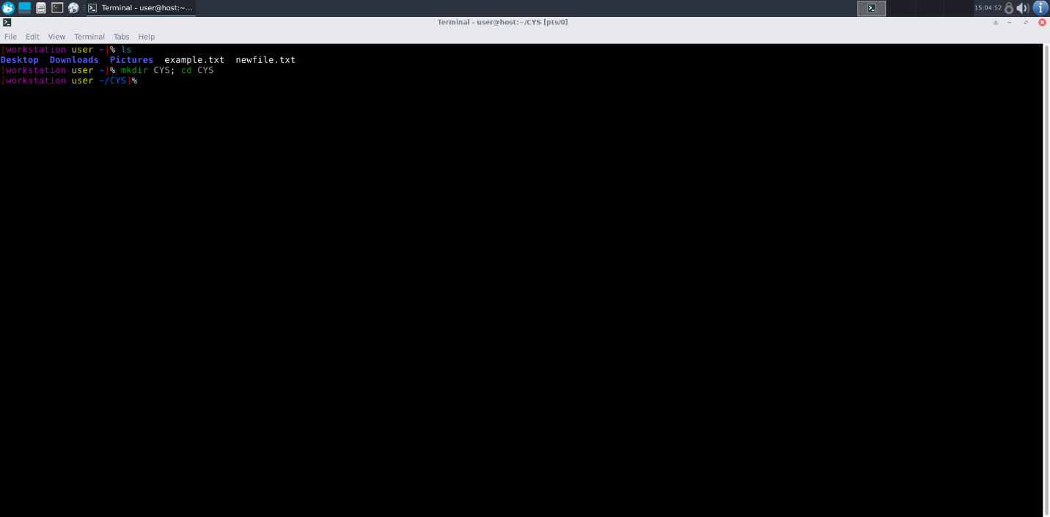

2. Create Folder “CYS” and navigate to it:

- Command: mkdir CYS; cd CYS

- Syntax: mkdir [directory]; cd [directory]

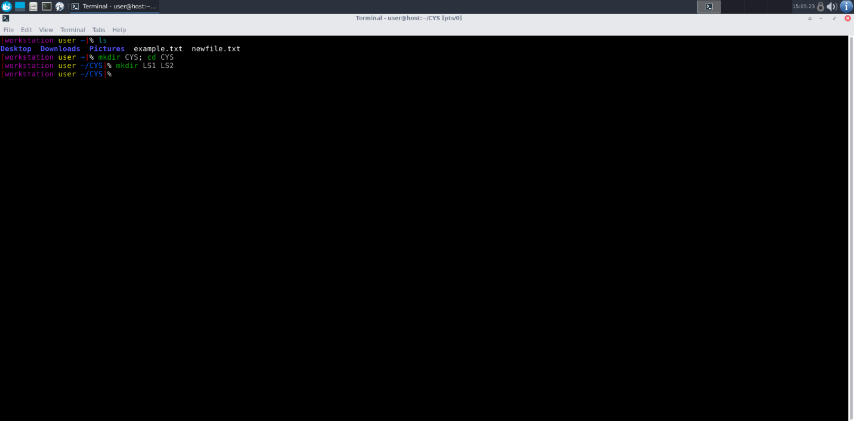

3. Create folder LS1 and LS2 under CYS:

- Command: mkdir LS1 LS2

- Syntax: mkdir [directory] [directory]

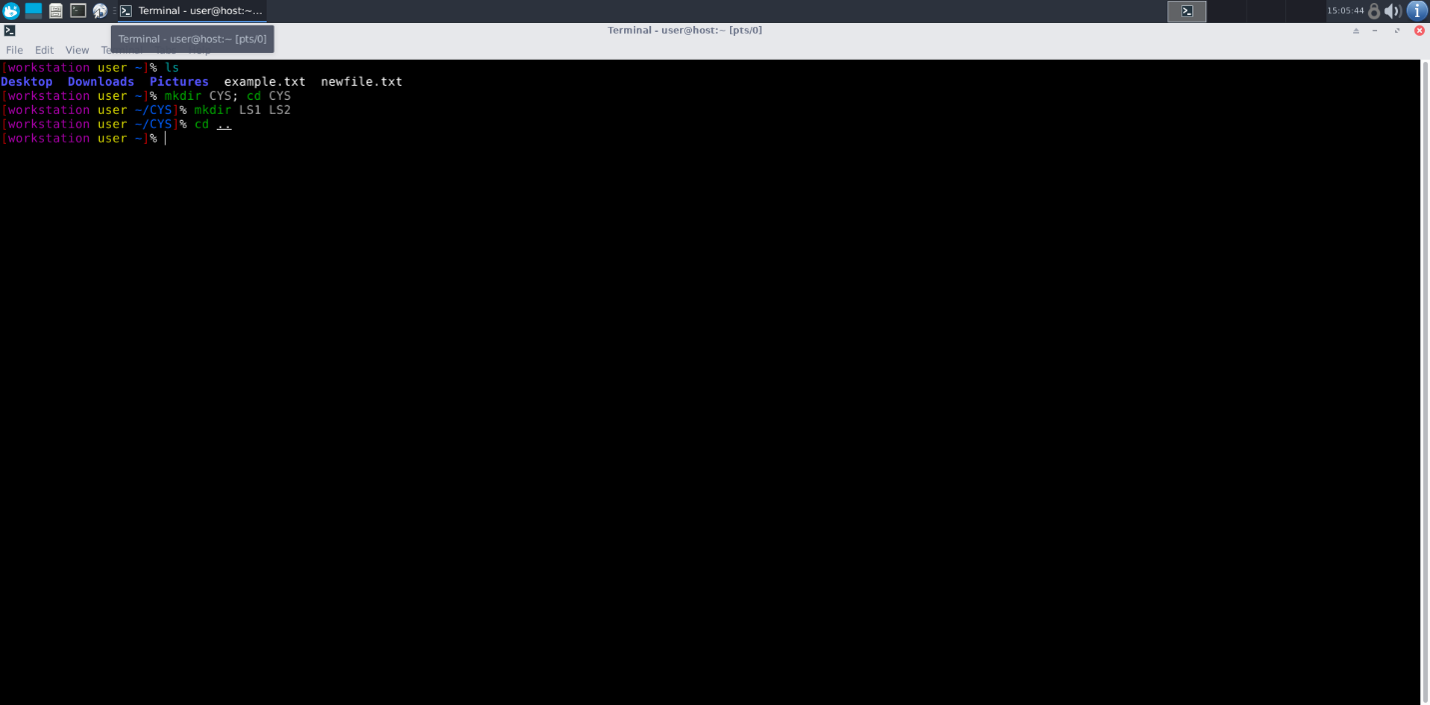

4. Go back to CYS:

- Command: cd ..

- Syntax: cd ..

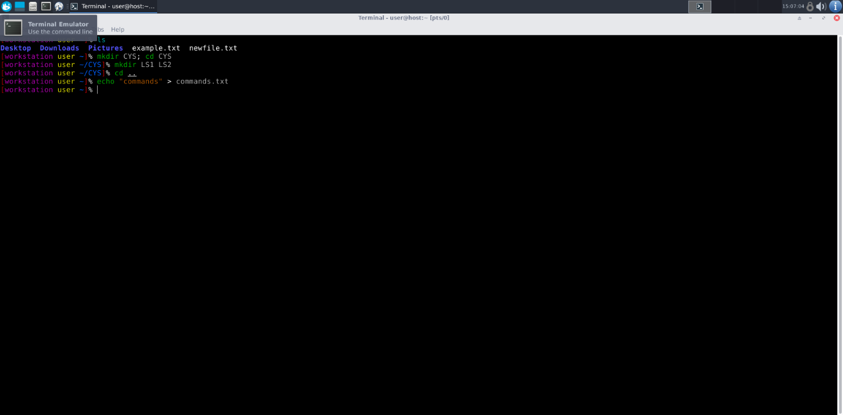

5. Add commands learned during the lab session to commands.txt :

- Command: echo "commands" > commands.txt

- Syntax: echo "[text]" > [file]

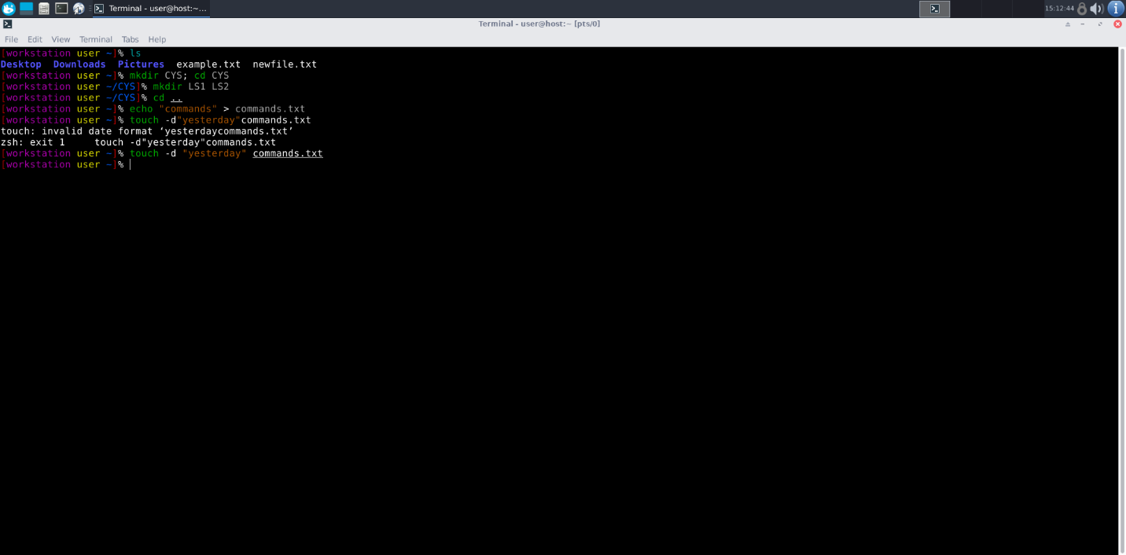

6. Change the timestamp of the file to yesterday:

- Command: touch -d "yesterday" commands.txt

- Syntax: touch -d "[date]" [file]

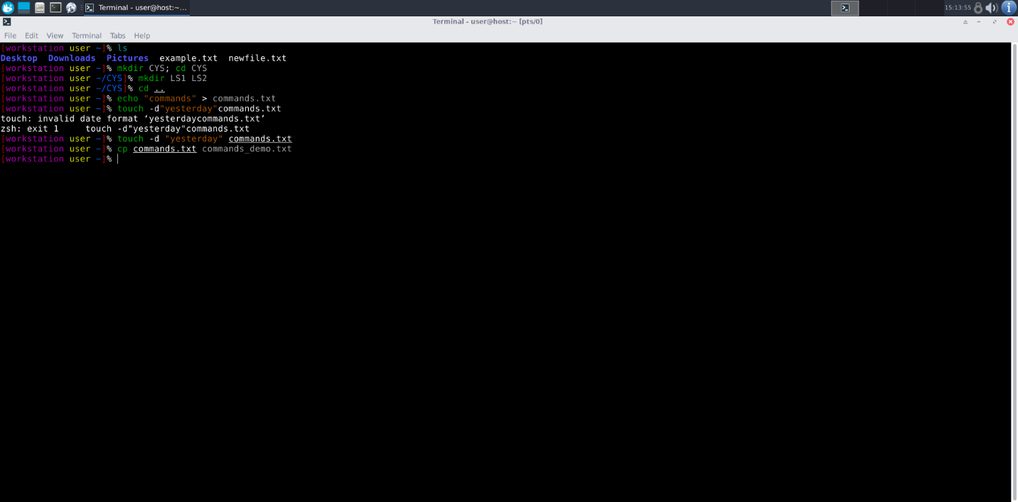

7. Copy contents from commands.txt to commands_demo.txt :

- Command: cp commands.txt commands_demo.txt

- Syntax: cp [source] [destination]

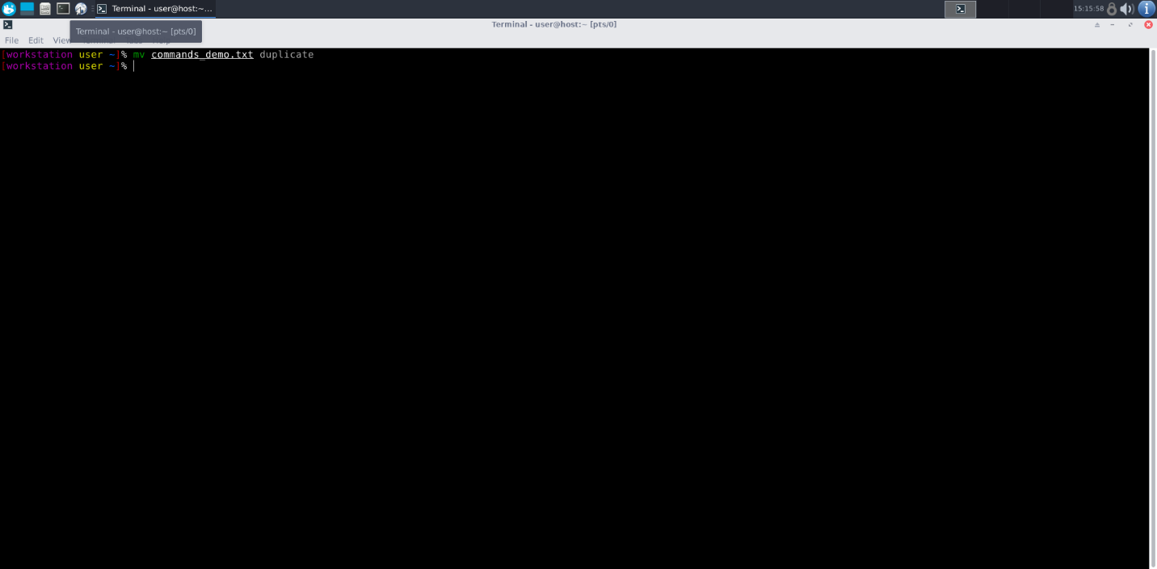

8. Rename the file commands_demo.txt to duplicate :

- Command: mv commands_demo.txt duplicate

- Syntax: mv [old_name] [new_name]

9. Rename all .html files to .hldd :

- Command: rename s/\.html$/\.hldd/ *.html

- Syntax: rename s/[pattern]/[replacement]/ [files]

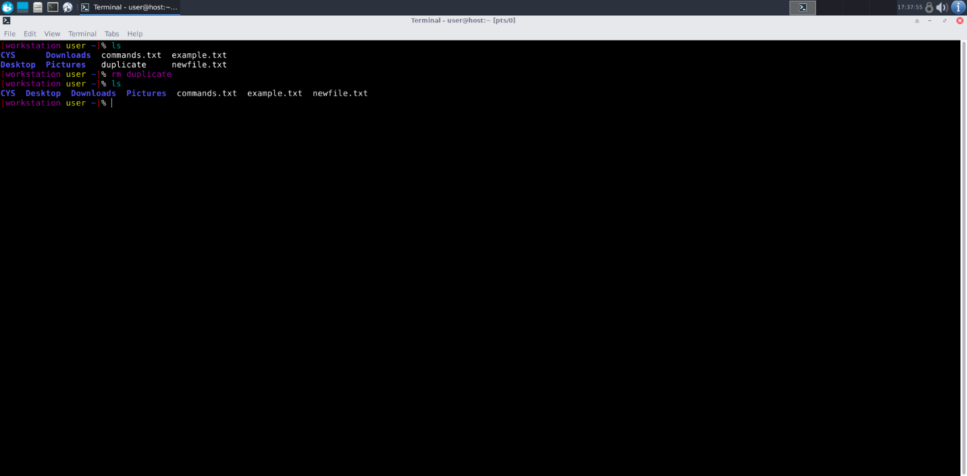

10. Delete the file duplicate :

- Command: rm duplicate

- Syntax: rm [file]

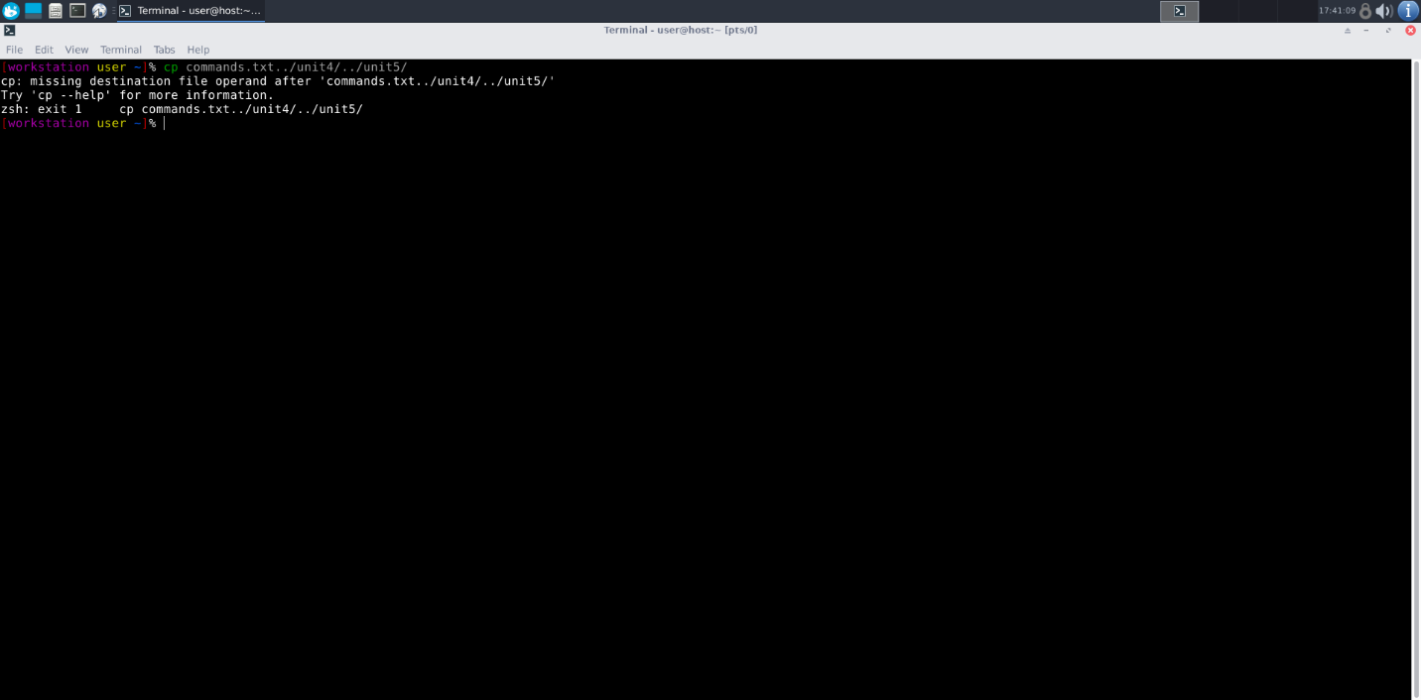

11. Copy contents commands.txt to unit4 and unit5 (using relative path):

- Command: cp commands.txt ../unit4/ ../unit5/

- Syntax: cp [file] [destination1] [destination2]

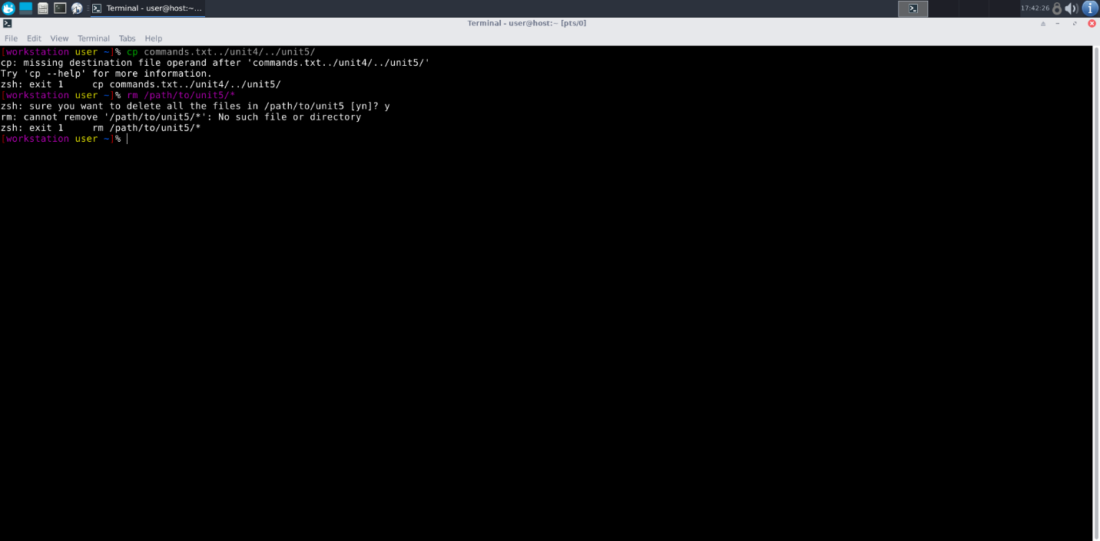

12. Delete contents from unit5 (using absolute path):

- Command: rm /path/to/unit5/*

- Syntax: rm [absolute_path]/*

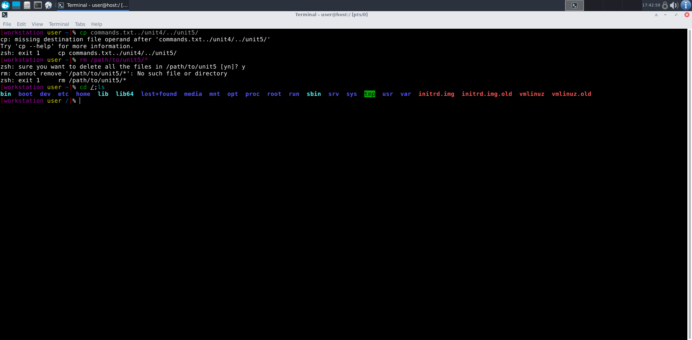

13. Navigate to root and list all files:

- Command: cd /; ls

- Syntax: cd /; ls

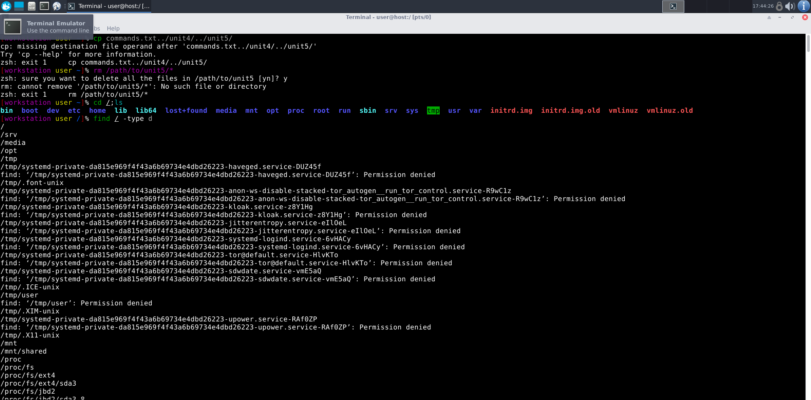

14. Explore all folders without deleting:

- Command: find / -type d

- Syntax: find / -type d

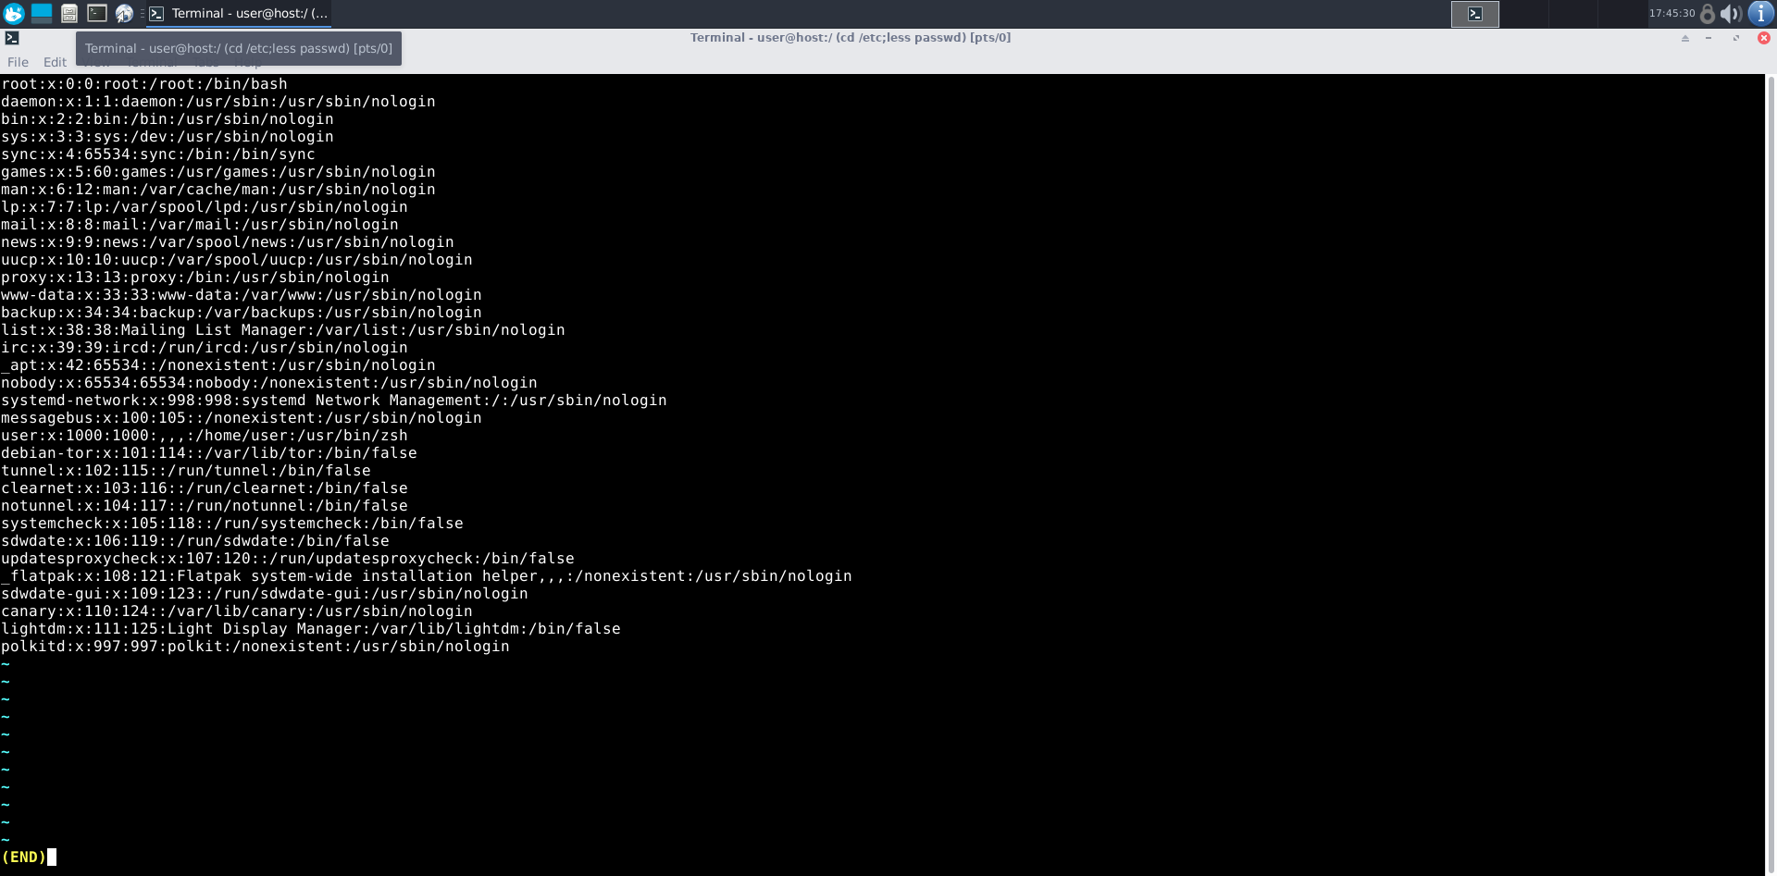

15. Navigate to /etc/passwd , open and explore:

- Command: cd /etc; less passwd

- Syntax: cd /etc; less [file]

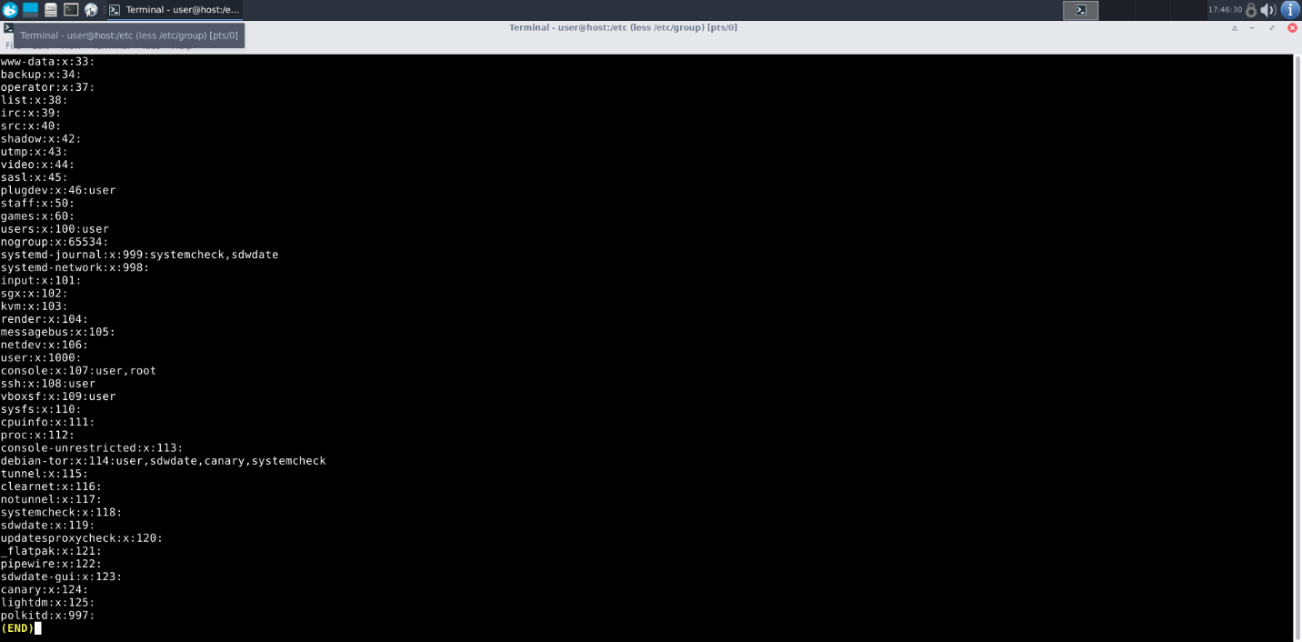

16. Navigate to /etc/group and explore:

- Command: less /etc/group

- Syntax: less [file]

**Differences**

1. GUI vs. CLI:

- GUI (Graphical User Interface): Visual interface with icons and buttons, user-friendly.

- CLI (Command Line Interface): Text-based interface for advanced users, more control and flexibility.

2. man vs info:

- man: Displays manual pages for commands; concise and traditional.

- info: Provides more detailed documentation; includes navigation.

3. which vs. whereis:

- which: Displays the path of the executable.

- whereis: Provides locations of the binary, source, and man pages.

4. Terminal vs. Shell:

- Terminal: Interface for inputting text commands.

- Shell: Command-line interpreter within the terminal.

**Simple Shell Script**

#!/bin/bash

echo "My name is Amruthesh"

echo "My hobbies are Swimming, Reading Novels, Watching Movies"

**Interesting Commands to Explore**

1. Banner:

- Command: banner

- Usage: Displays text in a large ASCII format.

- Example: banner Hello

2. History:

- Command: history

- Usage: Displays command history.

- Example: history